Assignments 11

1. Write a query that uses a subquery to obtain all orders for the
customer named Cisneros. Assume you do not know his customer
number (cnum).

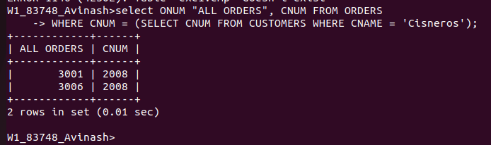

2.Write a query that produces the names and ratings of all customers
who have above-average orders.

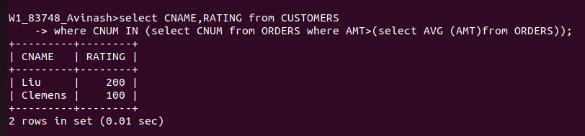

3. Write a query that selects the total amount in orders for each
salesperson for whom this total is greater than the amount of the
largest order in the table.

